**Research Paper**

**ON**

**FACIAL ATTENDANCE RECOGNITION SYSTEM**



Department of Computer Science and Engineering

**CHANDIGARH ENGINEERING COLLEGE JHANJERI, MOHALI**

**WRITTEN AND IMPLEMENTED BY:**

**Prince Kumar**

**B. Tech**

**Computer Science and Engineering**

**University Roll No. : 1816590**

**UNDER THE GUIDANCE OF:**

**Dr. Pooja Kapila**

**Software Engineer (Professor)**

**B. Tech – Computer Science and Engineering**

**Chandigarh Engineering College**

**Jhanjeri, Mohali – 140307**



**Affiliated to I.K Gujral Punjab Technical University, Jalandhar**

**(Batch: 2018-2022)**

**ACKNOWLEDGEMENT**

It is great pleasure to publish my research paper on **“Live Logging Facial Recognition Attendance System”** written and implemented by me while pursing my B. Tech degree in Computer Science & Engineering in final year. I am thankful to my university for guide and support me. I express my deepest thanks to all coordinators, for providing all the possible help and assistance and their constant encouragements.

I am extremely thankful to **Dr. Rajneesh Talwar,** Director of Engineering, Chandigarh Engineering College Jhanjeri, Mohali (Punjab) for valuable suggestions and motivation.

I am also thankful to all my teachers who have taught me till date in my degree, management of institute and **Dr. Rajneesh Talwar,** Director of Engineering for providing me the opportunity to get the knowledge.

**Prince Kumar**

**B Tech 4th year**

**Computer Science and Engineering**

**Un Roll No: 1816590**

**Introduction**

**Introduction**

This project is based on the technology of Computer Vision in AI. My AI handle Frontend and Backend Databases, File handling, Exception Handling, GUI with Tkinter, Data Access control without a need of single person and no any database maintenance required after implementing it. It uses freely by any school, colleges, IT companies, and any types of attendance marking system. It marking attendance from detecting faces of person. It detects the face of person in real time using webcam. The Computer Vision techniques we use in this project is image analysis, face detection, face-recognition.

This Model is checks that captured image attendance is marked or not and take the decision based on the data which it will be get, processed it and give the output. If the attendance of that capture image is not marked then model mark it. If the attendance of that captured image is already marked then the model shows attendance already marked of that captured person image and it do not overwrite the data. So, we can proceed it to the next one and same process is repeated for the every person.

**Objectives of Face Recognition Attendance System**

From a long term we use the old method for taking attendance using paper or pen. One by one we call the roll no or name of student and then we mark it present or absent. We also uses many papers or pages for store the data of attendance. And also teachers are facing many problems while taking attendance. Sometimes due to miscommunication teacher mark the wrong attendance.

For store the data of attendance we use lot of papers. So, we have to cut a large amount of tree in whole world for accruing the demand of papers. According to the survey a single tree produces 10,000 to 20,000 papers.

Papermaking has an impact on environment because it destroys trees continuously in every single day. According to the data from the Global Forest Resource Assessment roughly 80,000 to 160,000 trees are cut down each day around the world for papermaking by the paper industry. So we are made a digital method to mark attendance of peoples without using pen and paper. Therefore, we are work productively and comfortably.

**Purposed**

As we know few years ago biometric attendance system is launched which is very efficient, very fast, and secure method. We use this method for marking attendance using fingerprint of every single person by person. It reduces the physical effort of file handling and wasting time. It has one disadvantages which we easily mark proxy attendance of any person. System doesn’t differentiate that is that person same or different. So, I build the AI which mark attendance without any proxy, and secure method by using face.

Our AI, mark attendance of person using face of particular person. For reducing the proxy attendance marking system, we use a method to track eye blinking and eye motion tracking system which differentiate that is that any image or video file, if it is then it should not mark attendance. If it is not which means person present in real time and the image capture is in real time frame. It using the face patterns and LBPH algorithm for making the face patterns and using face recognition we calculate the face distance of persons/students face. Thus we differentiate the faces between the person/students.

We use this model to everywhere in the world where we need to mark attendance of person. In/out times when he/she will enter in and when he/she will be out such as Security system, Bank security, business purposes, IT organization, School, Institute, College, Universities, and so on…

We also use this technology in online meeting system, online classes, conference, seminar, webinar, and so on.

We also uses the features of entry and exit control in this system. Time limit for marking attendance. If you are not present within this time limit then your attendance will be mark zero. If you are present within this time limit then your attendance will be mark present. It also has a features of entry control what is the time limit you are able to mark attendance. If you are enter the class or something else within this time limit then you are able to mark your attendance.

**Review of Literature**

**Spyder:** You must have newest version of anaconda in your system. After successful installation you have a lot of choice for your programming interface such as Jupyter, Pycharm, Visual Studio, Spyder etc. Spyder is better for huge programming and it is more comfortable for any of those. It has more helpful tools which helps you while coding. In this project we were using Spyder from Anaconda for building this model. You can also use Jupyter or any other software as according to your comfort.

**Database**

**Database Categories:** We create Comma Separated Values (CSV) and store the data whatever output given by model. Data categories are tables of data, which are organized by rows and columns. Columns are also known as data fields. A row of data has entries for one or more columns in the category. When you add a data field onto a report you are seeing the information in one column of data for every row in the category.

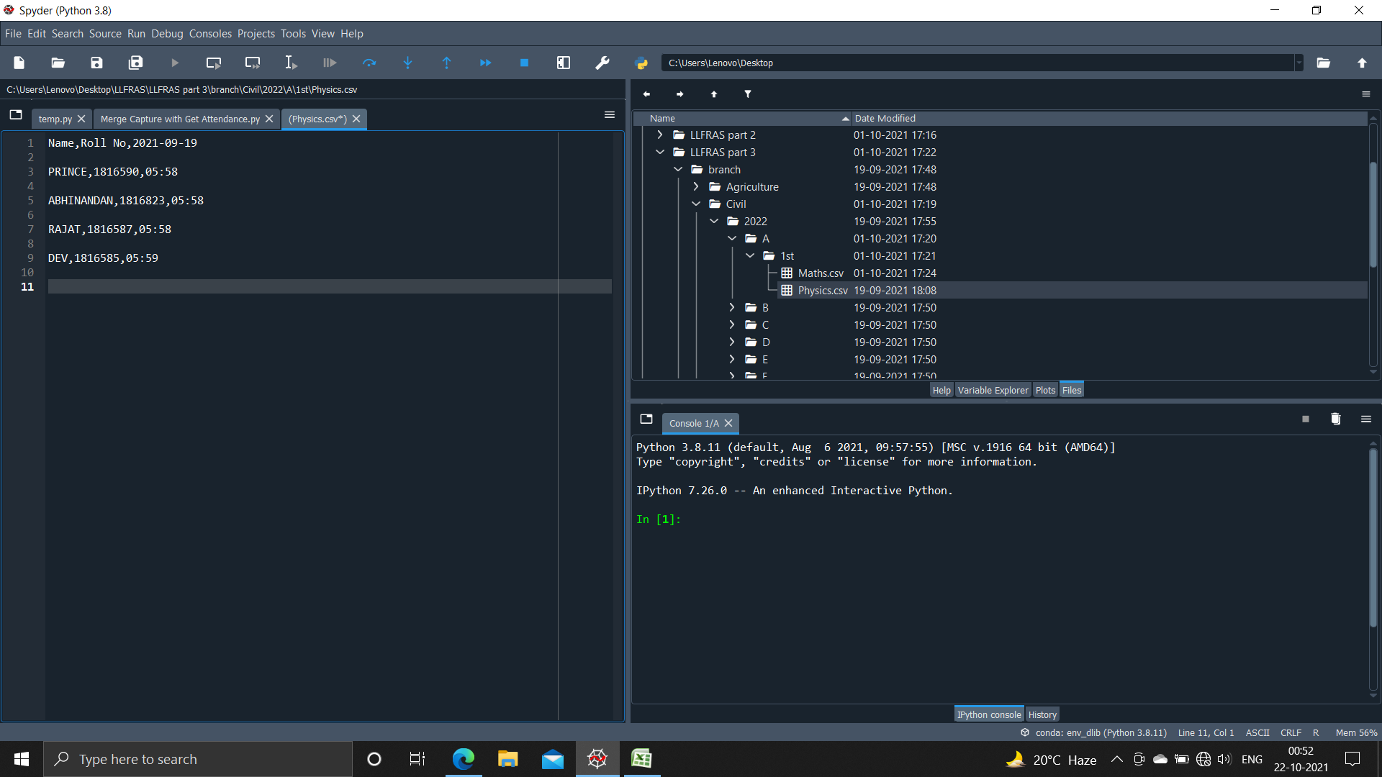

Figure 1: Database Categories

**Data Model:** Then we convert the CSV file to the Excel file. A database model is a type of data model that determines the logical structure of database and fundamentally determines in which manner data can be stored, organized and manipulated.

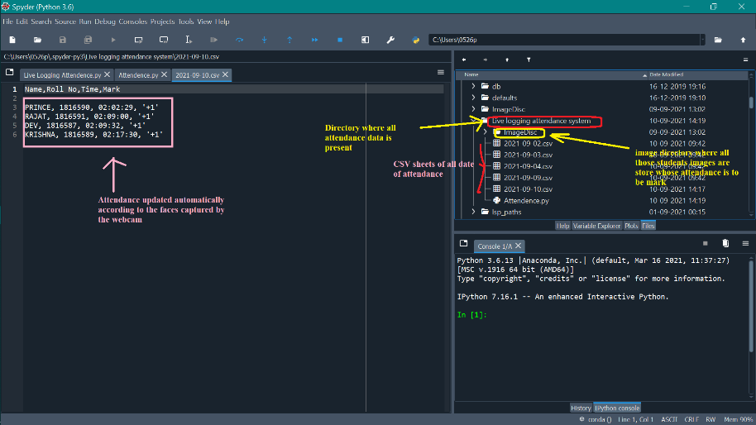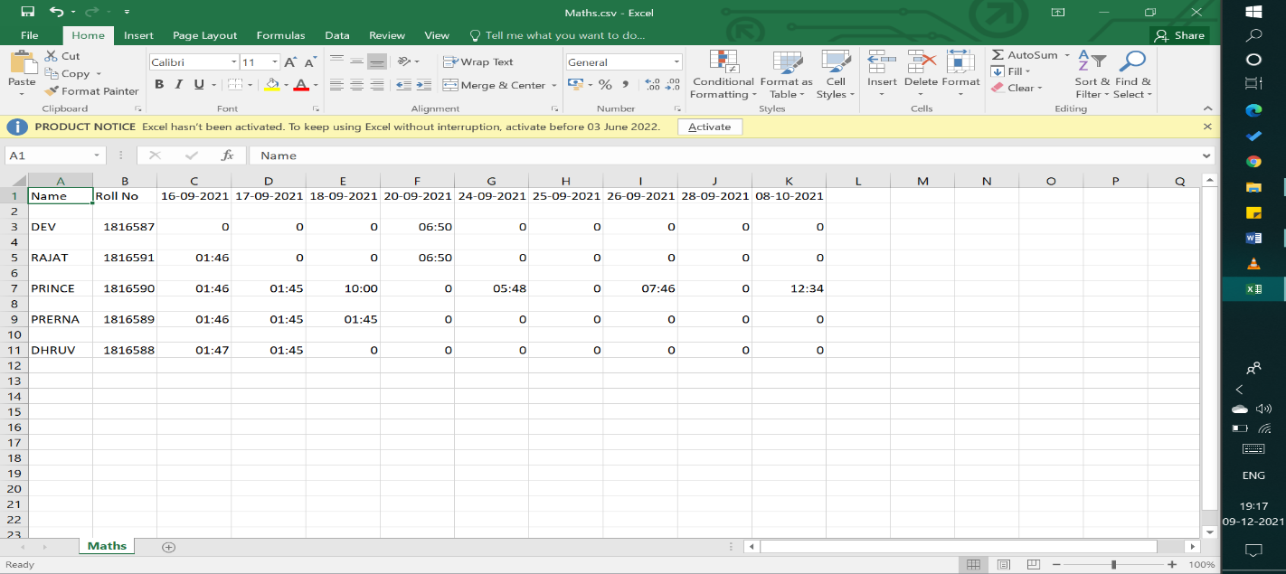

Fig 2: Attendance CSV Sheet Figure 3: Database Categories and Attendance Excel Sheet

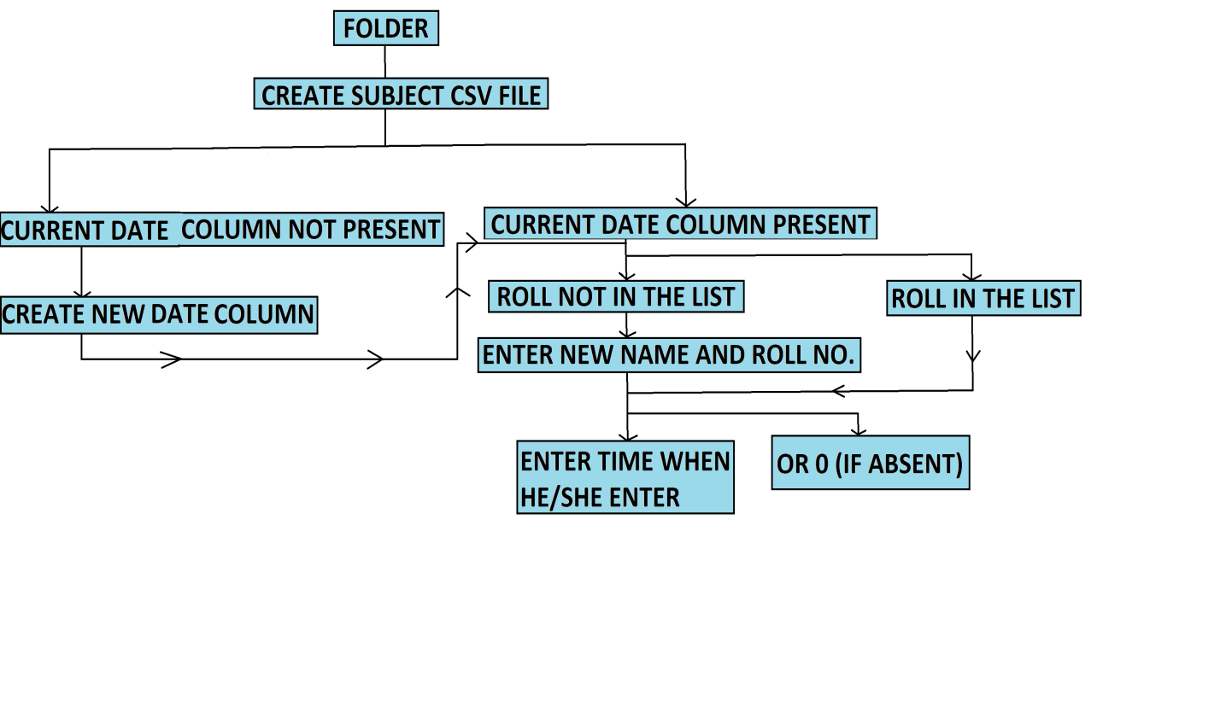

Figure 4: Data flow of LLFRAS

**ER Diagram:** ER Diagram stands for Entity Relationship Diagram, also known as ERD is a diagram that displays the relationship of entity sets stored in a database. In other words, ER diagrams help to explain the logical structure of databases.

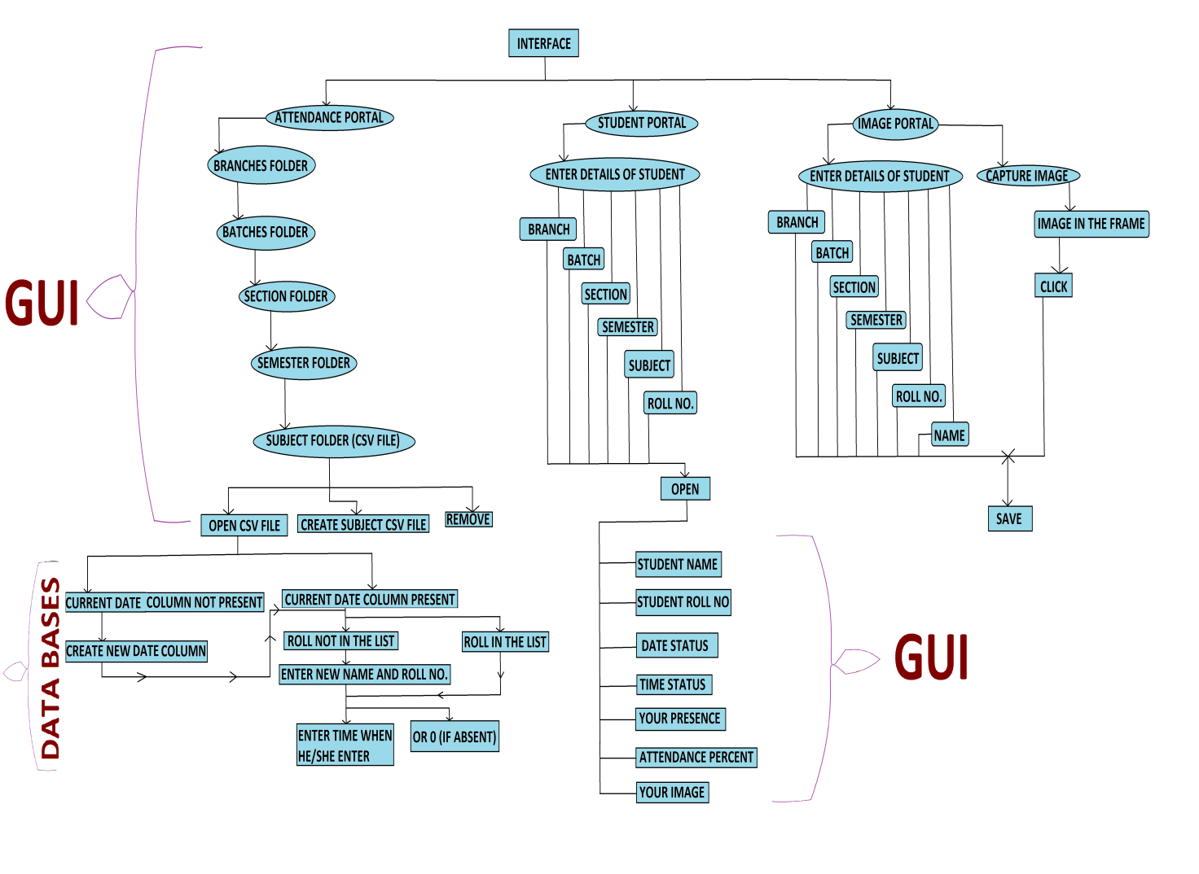

Figure 5: ER Diagram of LLFRAS

**Methods to Build Live Logging Facial Recognition Attendance Systems**

1. Loading Image Data
2. Encoding of Load Image
3. Features Detection
4. Video Streaming & Real Times
5. Create and Update CSV sheet

**Facial Landmarks**

Facial landmarks allow us to automatically infer the location of facial structures, including: Eyes, Eyebrows, Nose, Mouth, and Jawline.

* + From there, we apply face detection to compute the bounding box location of the face in the image.The next step is to apply face detection. Here we’ve used a deep learning method to perform face detection with OpenCV. Once we know where in the image the face is, we can extract the face Region of Interest (RoI):

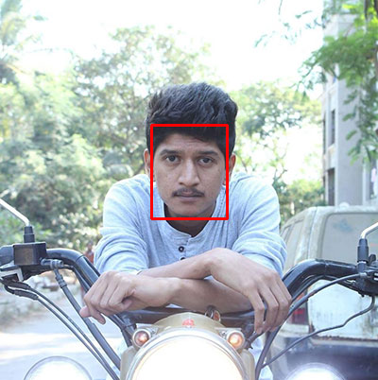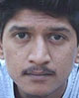

Fig 6: Square RoI Fig 7: RoI

* + The next step is to extract the face RoI with OpenCV and NumPy slicing. And from there, we apply facial landmarks as shown in fig 8, allowing us to localize the eyes, nose, mouth, etc. Then, we [detect facial landmarks](https://www.pyimagesearch.com/2017/04/03/facial-landmarks-dlib-opencv-python/) using dlib so that we know where to place a mask on the face. Calculate the encoding of image and face distance of every image. Apply the same process on the real time image in the video frame. And compare the encoding of both the image (image in database and capture image from real time video frame). If both are matched then mark attendance else not continue to capture the face in the real time video frame.

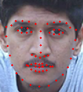

Fig 8: Facial Landmarks

**Libraries**

For building this model we uses some of the useful libraries such as Tkinter for building GUI interface where user interact with the model. Face Recognition for identify faces of human. Open CV for reading images from directory, capturing and processing images/videos using webcam in real time. Pillow for using images in GUI with Tkinter. Pillow supports a large number of image file formats including BMP, PNG, JPEG, and TIFF. CSV for making comma separated data sheet for mark attendance and update attendance data. Some of the other basic libraries such as numpy, os, datetime, pytz, pathlib. The libraries we need to build this system are as given below:

**Results**

## **These are the images of the person who want to mark their attendance and their data is already present in the data base. If not present in the data base then we create a new data of the person using image portal.**

## 

## **Fig 9: Person, they want to mark their attendance**

These are the interfaces provided by the AI where person interact with the models and perform their task. Fetch and update the data according to their need.

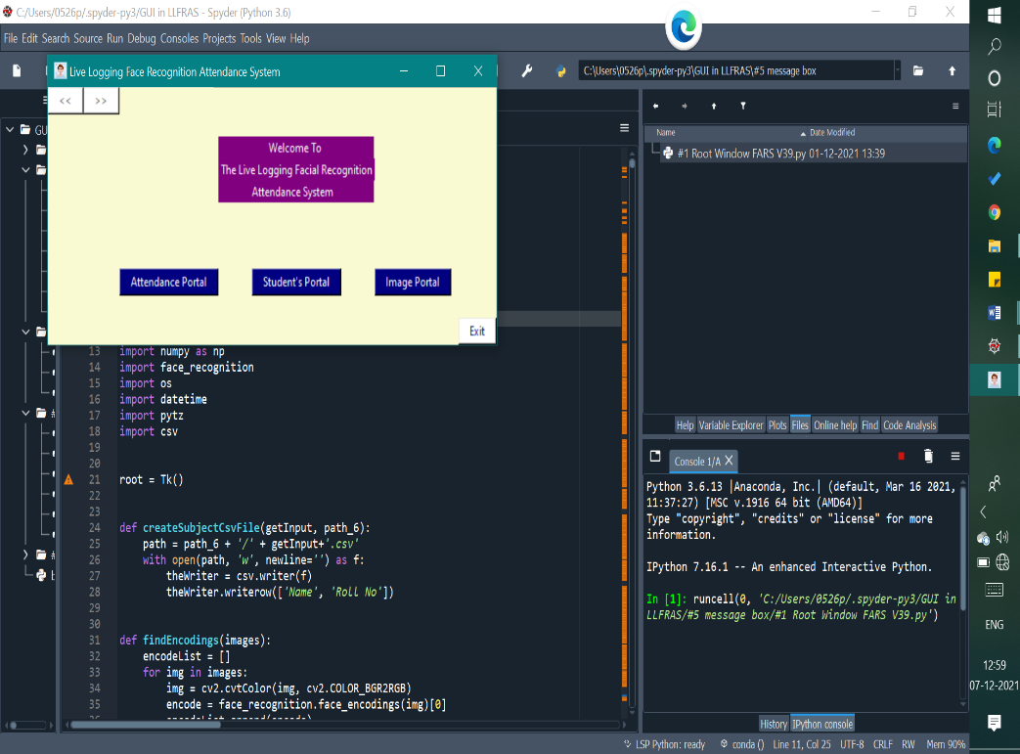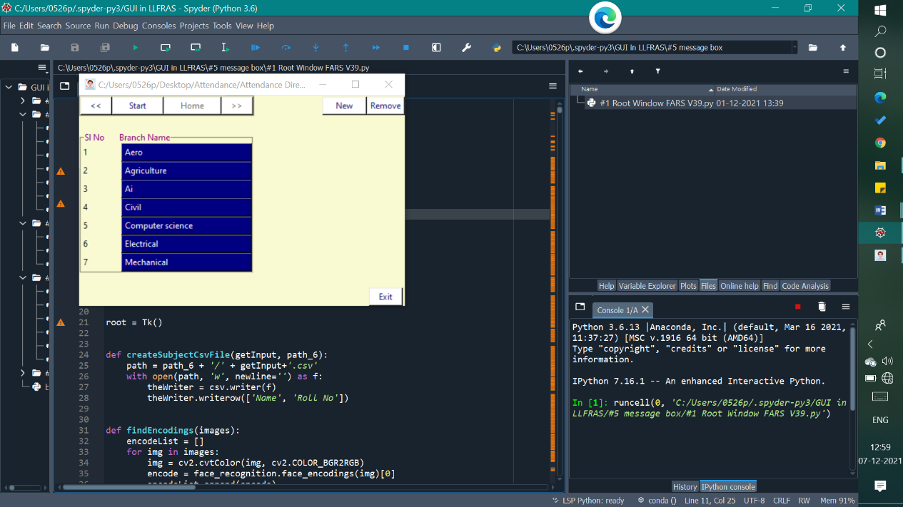

Fig 10: Front PageFig 11: Branch Page

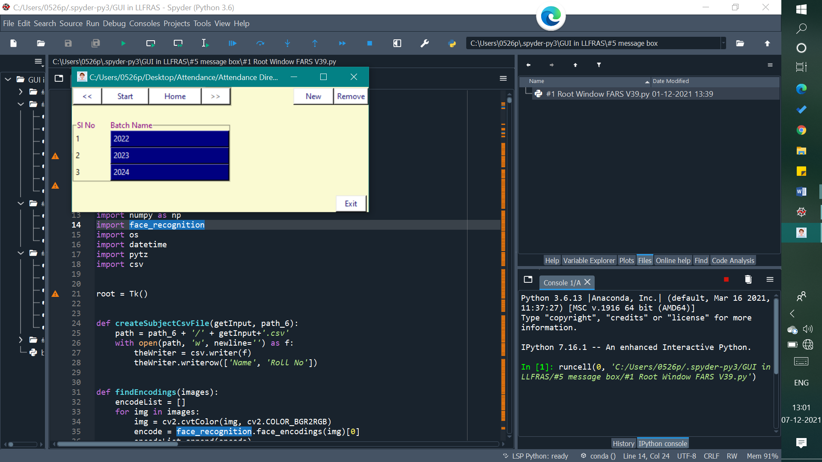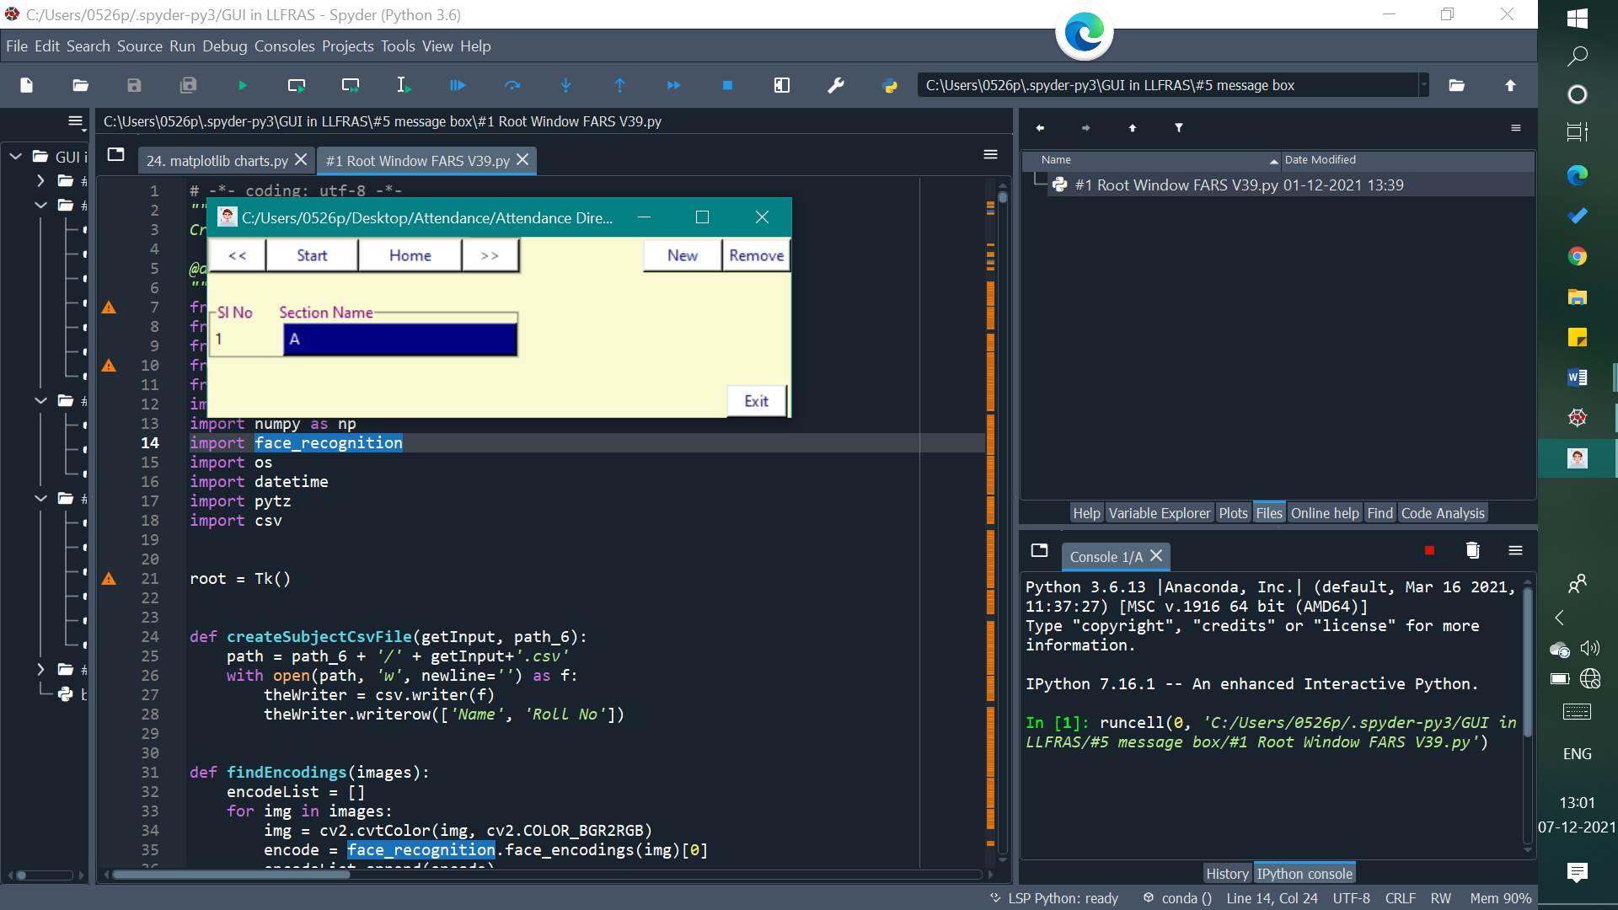

Fig 12: Batch Page **Fig 13: Section Page**

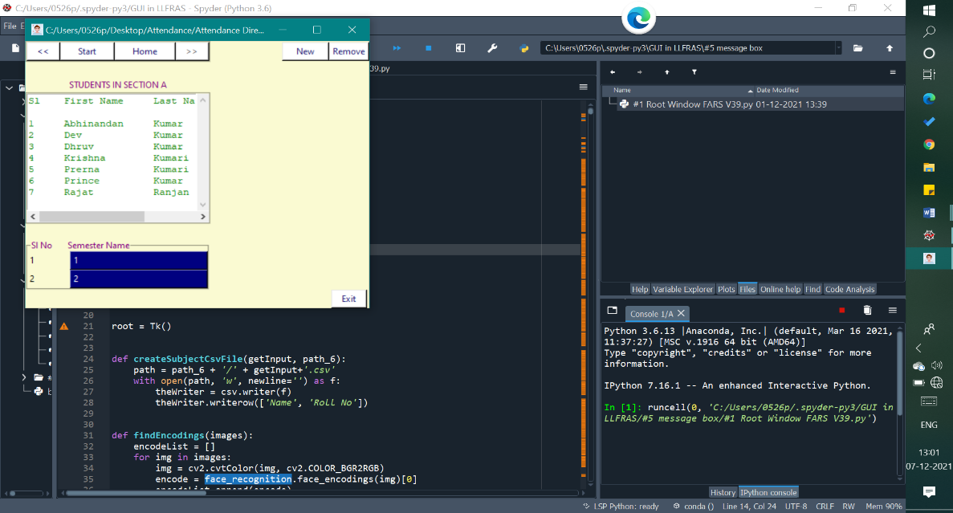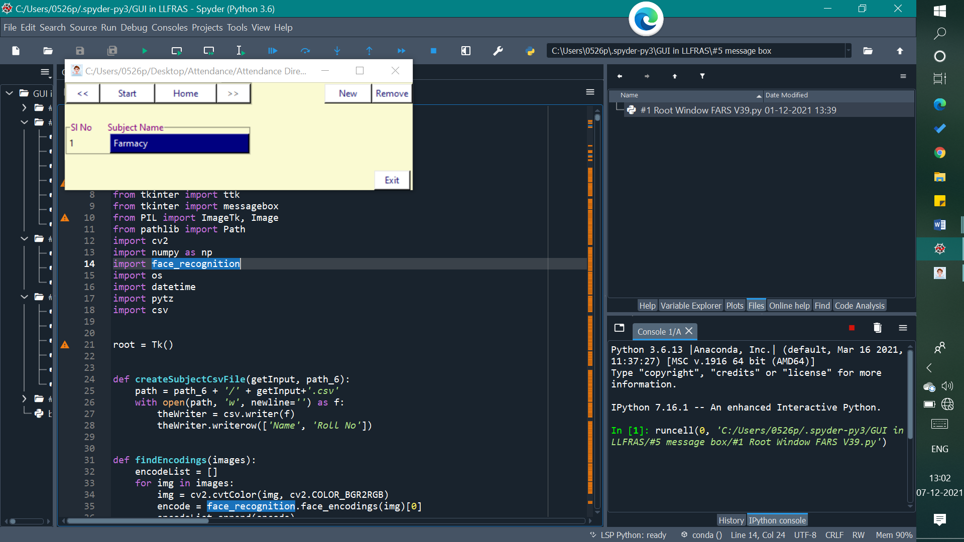

**Fig 14: Semester Page Fig 15: Subject Page**

**In fig 16 and 17 we saw if the person attendance is not marked then it update the data. If attendance is already marked than it doesn’t overwrite the data and shows “Attendance Already Marked”.**

## 

## **Fig 16: Attendance MarkedFig 17: Attendance Already Marked**

## **When you go in student portal in fig 18 then a new interface is open where you fill your basic details as like fig 19 so you can get the details about yourself as like in fig 20.**

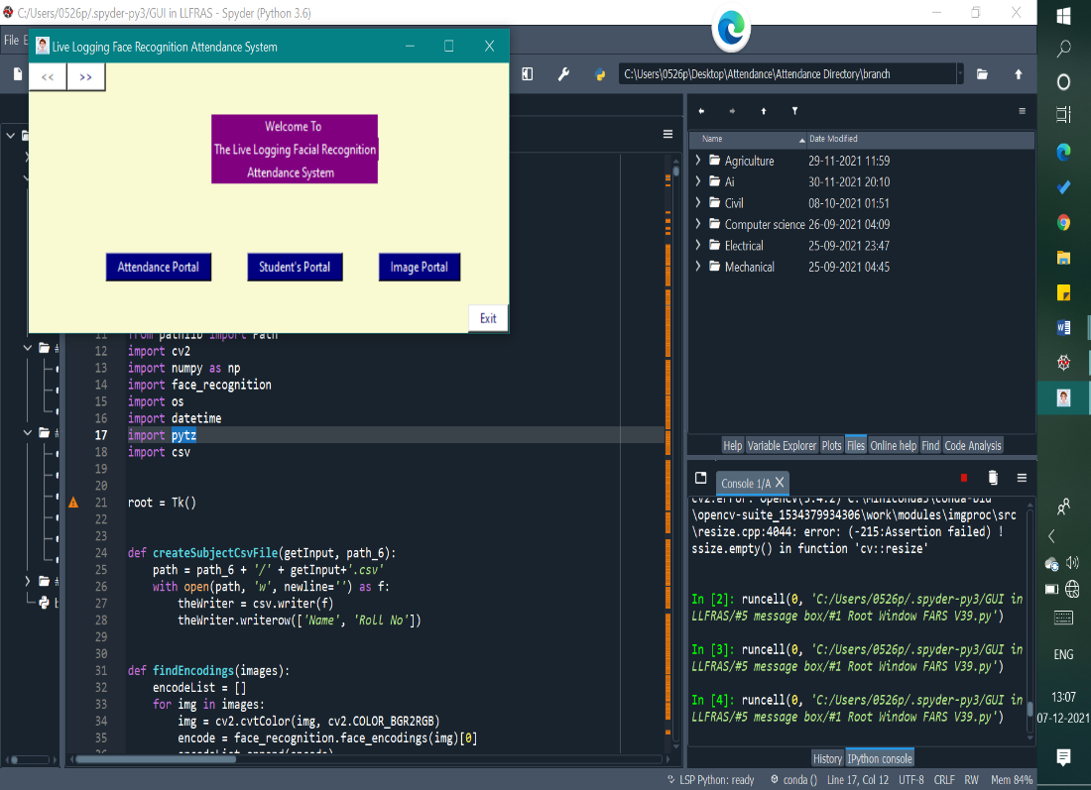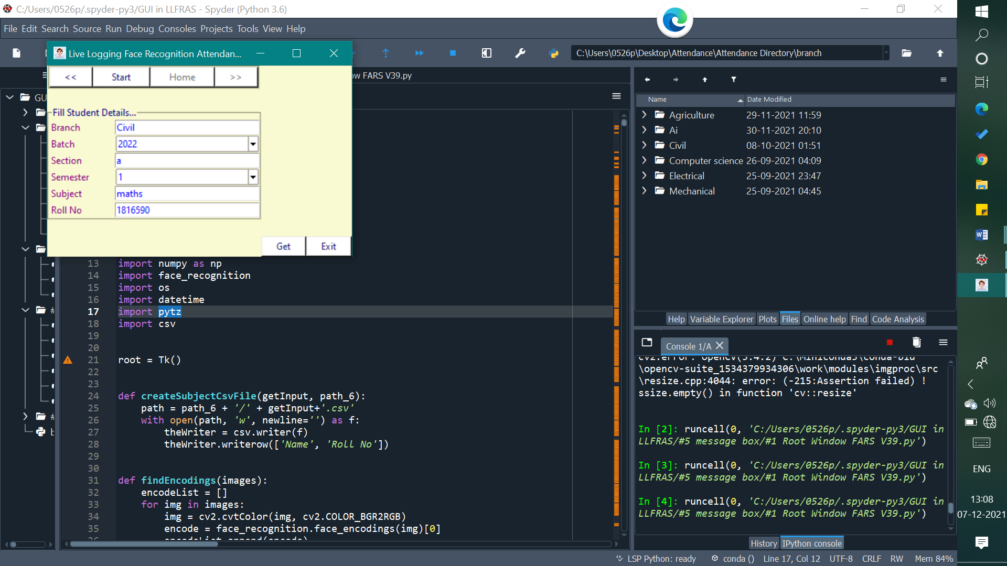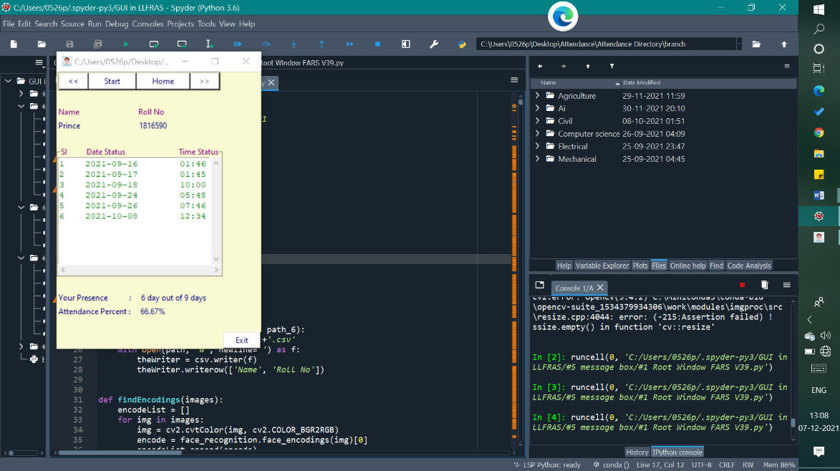

Fig 18: Front PageFig 19: Fill Student DetailsFig 20: Student Attendance Details

**Conclusion**

We made an AI that handles frontend and backend databases, data access controls, file handling, exception handling, Computer Vision and GUI. System controls the interface how to represent data in interfaces, thus user interact with models without any trouble and comfortably. We do not need to care about that what will be going on the backend. Capture the images from video frames and compares both images and mark attendance for more accurate input images. If that person attendance is doesn’t marks then it marks the attendance else it marks to 0 for that person. For all particular date it make a new date column where we marks attendance of that particular person. If any person is new in the class, then it check first that person data is already present in the sheet or not. If that person data is not present in the list then it make a new row for that person and marks the attendance from that date when he presence in the class and rest of the previous date column is marked zero.

There is a three portals Attendance Portal, Student Portal, and Image Portal. In Attendance Portal we generally use these portal for marking attendance and all the process we explain in first paragraph. In Student portal we represent the data of that particular person. So, for accessing the data of particular person first we make an interface where people fill his/her basic information then after he/she will be able to get the data. The data will be like your name, roll no, date-status, and times status. After that table it also shows your total no of date from the total number of date. In the very next row your total percentage from the total no days.

In the Image Portal, we create data of new student or person so, they mark their attendance further. If image of newcomer are not present in the directory then we do not need to make directory of images, in my model an image portal is given where you can create a new data of newcomer. There is provide an interface where we enter the basic data of student or person such as for student branch, batch, section, roll no, first name, middle name, last name, phone no, email id. After that in the next row we click the button and capture the screenshot of person or students.